A successful Git branching model

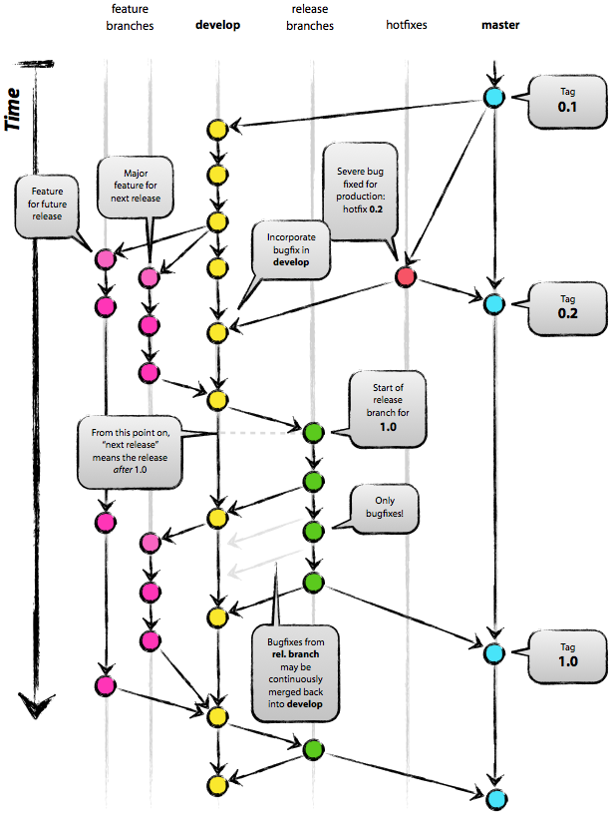

The main branches
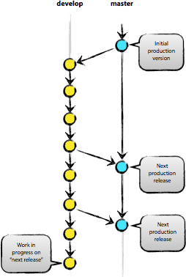
At the core, the development model is greatly inspired by existing models out there. The central repo holds two main branches with an infinite lifetime:
- master
- develop
The master branch at origin should be familiar to every Git user. Parallel to the master branch, another branch exists called develop.
We consider origin/master to be the main branch where the source code of HEAD always reflects a production-ready state.
We consider origin/develop to be the main branch where the source code of HEAD always reflects a state with the latest delivered development changes for the next release. Some would call this the “integration branch”. This is where any automatic nightly builds are built from.
When the source code in the develop branch reaches a stable point and is ready to be released, all of the changes should be merged back into master somehow and then tagged with a release number. How this is done in detail will be discussed further on.
Therefore, each time when changes are merged back into master, this is a new production release by definition. We tend to be very strict at this, so that theoretically, we could use a Git hook script to automatically build and roll-out our software to our production servers everytime there was a commit on master.

Supporting branches
Next to the main branches master and develop, our development model uses a variety of supporting branches to aid parallel development between team members, ease tracking of features, prepare for production releases and to assist in quickly fixing live production problems. Unlike the main branches, these branches always have a limited life time, since they will be removed eventually.
The different types of branches we may use are:
- Feature branches
- Release branches
- Hotfix branches
Each of these branches have a specific purpose and are bound to strict rules as to which branches may be their originating branch and which branches must be their merge targets. We will walk through them in a minute.
By no means are these branches “special” from a technical perspective. The branch types are categorized by how we use them. They are of course plain old Git branches.

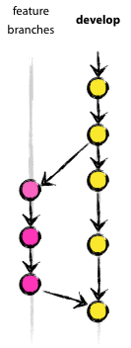
Feature branches

May branch off from:develop
Must merge back into:develop
Branch naming convention: anything except master, develop, release-*, or hotfix-*
Feature branches (or sometimes called topic branches) are used to develop new features for the upcoming or a distant future release. When starting development of a feature, the target release in which this feature will be incorporated may well be unknown at that point. The essence of a feature branch is that it exists as long as the feature is in development, but will eventually be merged back into develop (to definitely add the new feature to the upcoming release) or discarded (in case of a disappointing experiment).
Feature branches typically exist in developer repos only, not in origin.

Creating a feature branch
When starting work on a new feature, branch off from the develop branch.
$ git checkout -b myfeature develop
Switched to a new branch "myfeature"

Incorporating a finished feature on develop
Finished features may be merged into the develop branch definitely add them to the upcoming release:
$ git checkout develop
Switched to branch 'develop'
$ git merge --no-ff myfeature
Updating ea1b82a..05e9557
(Summary of changes)
$ git branch -d myfeature
Deleted branch myfeature (was 05e9557).
$ git push origin develop

The --no-ff flag causes the merge to always create a new commit object, even if the merge could be performed with a fast-forward. This avoids losing information about the historical existence of a feature branch and groups together all commits that together added the feature. Compare:
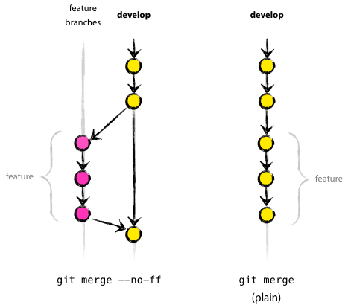
In the latter case, it is impossible to see from the Git history which of the commit objects together have implemented a feature—you would have to manually read all the log messages. Reverting a whole feature (i.e. a group of commits), is a true headache in the latter situation, whereas it is easily done if the --no-ff flag was used.
Yes, it will create a few more (empty) commit objects, but the gain is much bigger that that cost.
Unfortunately, I have not found a way to make --no-ff the default behaviour of git merge yet, but it really should be.

Release branches
May branch off from: develop
Must merge back into: develop and master
Branch naming convention: release-*
Release branches support preparation of a new production release. They allow for last-minute dotting of i’s and crossing t’s. Furthermore, they allow for minor bug fixes and preparing meta-data for a release (version number, build dates, etc.). By doing all of this work on a release branch, the develop branch is cleared to receive features for the next big release.
The key moment to branch off a new release branch from develop is when develop (almost) reflects the desired state of the new release. At least all features that are targeted for the release-to-be-built must be merged in to develop at this point in time. All features targeted at future releases may not—they must wait until after the release branch is branched off.
It is exactly at the start of a release branch that the upcoming release gets assigned a version number—not any earlier. Up until that moment, the develop branch reflected changes for the “next release”, but it is unclear whether that “next release” will eventually become 0.3 or 1.0, until the release branch is started. That decision is made on the start of the release branch and is carried out by the project’s rules on version number bumping.

Creating a release branch
Release branches are created from the develop branch. For example, say version 1.1.5 is the current production release and we have a big release coming up. The state of develop is ready for the “next release” and we have decided that this will become version 1.2 (rather than 1.1.6 or 2.0). So we branch off and give the release branch a name reflecting the new version number:

$ git checkout -b release-1.2 develop
Switched to a new branch "release-1.2"
$ ./bump-version.sh 1.2
Files modified successfully, version bumped to 1.2.
$ git commit -a -m "Bumped version number to 1.2"
[release-1.2 74d9424] Bumped version number to 1.2
1 files changed, 1 insertions(+), 1 deletions(-)

After creating a new branch and switching to it, we bump the version number. Here, bump-version.sh is a fictional shell script that changes some files in the working copy to reflect the new version. (This can of course be a manual change—the point being that some files change.) Then, the bumped version number is committed.
This new branch may exist there for a while, until the release may be rolled out definitely. During that time, bug fixes may be applied in this branch (rather than on the develop branch). Adding large new features here is strictly prohibited. They must be merged into develop, and therefore, wait for the next big release.
$ git checkout master
Switched to branch 'master'
$ git merge --no-ff release-1.2
Merge made by recursive.
(Summary of changes)
$ git tag -a 1.2
The release is now done, and tagged for future reference.
Edit: You might as well want to use the -s or -u <key> flags to sign your tag cryptographically.

To keep the changes made in the release branch, we need to merge those back into develop, though. In Git:
$ git checkout develop
Switched to branch 'develop'
$ git merge --no-ff release-1.2
Merge made by recursive.
(Summary of changes)

This step may well lead to a merge conflict (probably even, since we have changed the version number). If so, fix it and commit.
Now we are really done and the release branch may be removed, since we don’t need it anymore:
$ git branch -d release-1.2
Deleted branch release-1.2 (was ff452fe).

Hotfix branches

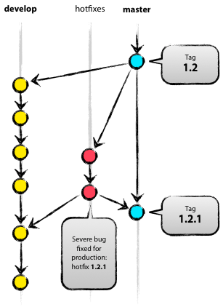
May branch off from: master
Must merge back into: develop and master
Branch naming convention: hotfix-*
Hotfix branches are very much like release branches in that they are also meant to prepare for a new production release, albeit unplanned. They arise from the necessity to act immediately upon an undesired state of a live production version. When a critical bug in a production version must be resolved immediately, a hotfix branch may be branched off from the corresponding tag on the master branch that marks the production version.
The essence is that work of team members (on the develop branch) can continue, while another person is preparing a quick production fix.

Creating the hotfix branch
Hotfix branches are created from the master branch. For example, say version 1.2 is the current production release running live and causing troubles due to a severe bug. But changes on develop are yet unstable. We may then branch off a hotfix branch and start fixing the problem:

$ git checkout -b hotfix-1.2.1 master
Switched to a new branch "hotfix-1.2.1"
$ ./bump-version.sh 1.2.1
Files modified successfully, version bumped to 1.2.1.
$ git commit -a -m "Bumped version number to 1.2.1"
[hotfix-1.2.1 41e61bb] Bumped version number to 1.2.1
1 files changed, 1 insertions(+), 1 deletions(-)

Don’t forget to bump the version number after branching off!
Then, fix the bug and commit the fix in one or more separate commits.
$ git commit -m "Fixed severe production problem"
[hotfix-1.2.1 abbe5d6] Fixed severe production problem
5 files changed, 32 insertions(+), 17 deletions(-)

Finishing a hotfix branch
When finished, the bugfix needs to be merged back into master, but also needs to be merged back into develop, in order to safeguard that the bugfix is included in the next release as well. This is completely similar to how release branches are finished.
First, update master and tag the release.
$ git checkout master
Switched to branch 'master'
$ git merge --no-ff hotfix-1.2.1
Merge made by recursive.
(Summary of changes)
$ git tag -a 1.2.1

Edit: You might as well want to use the -s or -u <key> flags to sign your tag cryptographically.
Next, include the bugfix in develop, too:
$ git checkout develop
Switched to branch 'develop'
$ git merge --no-ff hotfix-1.2.1
Merge made by recursive.
(Summary of changes)

The one exception to the rule here is that, when a release branch currently exists, the hotfix changes need to be merged into that release branch, instead of develop. Back-merging the bugfix into the release branch will eventually result in the bugfix being merged into develop too, when the release branch is finished. (If work in develop immediately requires this bugfix and cannot wait for the release branch to be finished, you may safely merge the bugfix into develop now already as well.)
Finally, remove the temporary branch:

$ git branch -d hotfix-1.2.1
Deleted branch hotfix-1.2.1 (was abbe5d6).

Summary
While there is nothing really shocking new to this branching model, the “big picture” figure that this post began with has turned out to be tremendously useful in our projects. It forms an elegant mental model that is easy to comprehend and allows team members to develop a shared understanding of the branching and releasing processes.
A high-quality PDF version of the figure is provided here. Go ahead and hang it on the wall for quick reference at any time.

1. Git 로 Patch 발행하기

Git 는 요즘에 사람들이 많이 사용하는 툴이다. Git 에서 patch file을 만드는 방법은 유용한 방법이다.

버그를 발견하거나 새로운 기능을 개발할 때는 별도의 브랜치에서 수행하는 것이 좋다.
예를 들어 당신이 내 저장소를 클론하여 새로운 브랜치를 만들어서 보완하려고 하면, 다음과 같은 방식으로 작업을 진행하시오.

당신이 empty poster라는 기능을 개발하고자 한다고 하자.

git clone git://github.com/ariejan/imdb.git
cd imdb
git checkout -b fix_empty_poster

자 이제 fix_empty_poster 라는 브랜치에서 필요한 수정을 할 수 있다.
테스트 프로그램을 작성하고 코드를 업데이트 하는 등의 모든 작업을 수행할 수 있다.
당신이 원하는 모든 변경 작업에 만족을 하면, 이제 패치를 발행할 시간이다.

패치 생성하기
git log 를 수행하여 fix_empty_poster 브랜치의 변경사항을 파악할 수 있다.

자 이제 패치를 만들 차례이다.
git format-patch master –stdout > fix_empty_poster.patch
위와 같이 명령을 수행하면 새로운 fix_empty_poster.patch 파이일 생성되고 마스터와의 모든 차이점을 파악할 수 있다.

패치를 적용하는 방법
git apply –stat fix_empty_poster.patch

패치를 적용할때 어떤 문제를 일으킬지 먼저 확인하기 위해서는 다음과 같은 명령을 수행한다.
git apply –check fix_empty_poster.patch

어떤 문제점도 발생하지 않았으면 그 패치는 적용이 된것이다.

그런데 문제가 발생한 후 패치를 적용하려면 다음과 같이 처리해야 한다.
git am –signoff < fix_empty_poster.patch

